

2 Minute Form
Trip Name:
Check-in Name and Phone:
Date: Branch:
Leaders
Cell Phone Number
VHF Call Sign &/or Vessel Name
Vehicle make, model, registration, colour
General Plan
Note: If plan changes, you must notify your Check-in person.
Latest Time Off the Water |  |  |  |  | TMP used²⁰ | East Auckland beaches from Little Bucklands to Cockle Bay
Tide/ Forecast Lake Level | Low |  |  | High
Communications Carried²¹
Communications | We will be communicating as a group on VHF Channel
Equipment Carried
Trip Report
(Use other side if more space required)

Activity | East Auckland beaches from Little Buckland’s to Cockle Bay | Centre | Manukau | Location |  |  |  | Auckland |  | Difficulty¹ |  |  |  | Beginner to intermediate – depending on distance
Activity Description | Paddle any part of the coast from Little Buckland’s Beach to Cockle Bay |  |  |  | Leader qualification req.² |  |  | leader
Get in Location | Any from Little Buckland’s to Cockle Bay. For details of each leg between beaches see below. |  |  |  | Chart/ Map no.⁴ |  |  | 5325 & 5324 |  | Distance |  |  |  | varies
Get out Location | Any from Little Buckland’s to Cockle Bay. For details of each leg between beaches see below. |  |  |  | Coastguard Channel |  |  | 80, 82 & 16 |  | Now-casting |  |  |  | 21
Emergency get out ⁵ | Any from Little Buckland’s to Cockle Bay. For details of each leg between beaches see below. |  |  |  | Emergency / Coastguard Station |  |  | Auckland |  | Phone |  | *500 / 09 303 4303
Emergency get out ⁵ |  |  |  |  | Drinking Water⁶ |  | Yes |  | Toilets⁷ |  |  |  | Yes
Emergency Response | Refer Emergency Response Booklet |  |  |  |  |  |  |  | Parking⁸ |  |  |  | Yes
Specific Equipment Required⁹ | none |  |  |  | Working Communications equipment in this area¹⁰ |  | Cell phone  Sat phone |  |  |  |  |  |  |  | PLB  VHF
Other resources  and notes¹¹ |  |  |  |  | Weather Parameters¹² | Beginner: no significant surf or swell, wind under 15 knots.  Intermediate: surf or ocean swells less than 1.5 metres or wind under 25 knots.  Advanced: any condition that’s suitable for the trip’s aims.
Previous incidents¹³

Safety Management¹⁴
Hazard |  | Significant?  - E/I/M |  | Management Strategy¹⁵ |  |  |  | Hazard | Significant?  - E/I/M | Management Strategy¹⁵
Cold Water |  | Yes - M |  | Carry spare dry clothes and shelter |  |  |  | Deep Water | Yes - E | Correctly fit PFDs
Medical Conditions |  | Yes - M |  | - Leader has first aid qualification  - Ask customers about medical conditions |  |  |  | Bad Weather | Yes - M | Understand weather forecasts.  Have back up plans or pull out if necessary
Capsizing |  | Yes - M |  | - Correctly fit PFDs  - Skills at performing rescues. |  |  |  | Heat / Sun | Yes - M | - Protective Clothing (worn), Sunglasses, Hat  - Sun Screen  - Plenty of drinks
Panic |  | Yes - M |  | Ensure conditions match level  of skills |  |  |  | Obstacles | Yes - M | Awareness of reefs, navigational hazards, nets
Swimmers |  | No |  | - Keep a good lookout |  |  |  | Other Vessels | Yes - M | - Understand the “rules of the sea”  - “Be seen” – Have two of the following; flag, brightly coloured kayak, brightly coloured Pfd or hat. At night: an all- round white light & a powerful torch.
Tides |  | No |  | - The beaches on the Eastern side are very tidal and the tides go out a long way. The Tamaki River can have a strong tidal flow at mid-tide, stay close to shore, and look out for inexperienced paddlers getting swept into moored craft. |  |  |  | Other Vessels | Yes - M
Fishermen – often found at rocks off Musick Point |  | No |  | Stay clear and be polite
Written up by: | Denise Marsden |  | Approved By: |  | Russ Williams | Signed: | RW |  | Date: | 1 Dec 2014 | Review in: | 12 months from date of approval

Little Buckland’s Beach to Musick Point
It is 3.5km from the southern end of Little Buckland’s Beach to the end of Musick Point. It is about 1km to the middle of Buckland Beach. There are toilets and cafes at Buckland’s Beach. There is parking at the southern end of Little Buckland’s as well as parking right along the road to the end of Buckland’s Beach. There are a lot of moored boats in this area and a busy shipping channel in the Tamaki River. It is easy to stay out of the shipping channel in this area. The area between the Northern end of Buckland’s Beach and Musick Point gets quite shallow at low tide so you will need to paddle further from the shore.

Musick Point to Eastern Beach
The end of Musick Point to the middle of Eastern Beach is 2.8km. There are toilets, changing rooms and a shop/café at Eastern Beach. There is parking right along the beachfront, but it can be rather busy in the middle of summer. There is a water ski /jet ski lane towards the southern end of the beach. This is marked with black/orange poles and buoys. You will need to take care crossing this lane. There may be swimmers about, keep an eye out. The tide at Eastern Beach goes out a very long way, so high tide launching/landing is recommended.

Eastern Beach to Mellon’s Bay
The distance from the middle of Eastern Beach to Mellon’s Bay is 2.4km. There are toilets, changing rooms and a parking area at Mellon’s Bay. This beach is also tidal so a mid-high tide is recommended.

Mellon’s Bay to Howick Beach
It is 1.6km from Mellon’s Bay to Howick Beach. Howick Beach has toilets and changing rooms. There is also a parking area. The Howick Volunteer Coastguard is based at Howick Beach.

Howick Beach to Cockle Bay
It is 1.4km from Howick Beach to Cockle Bay. There are toilets and changing rooms at Cockle Bay, as well as a parking area. There are picnic tables, a grassy area and children’s playground at the beach. This beach is also very tidal and the tide goes out a long way. It can be a bit muddy at low tide. Watch for swimmers as this is a safe swimming beach.
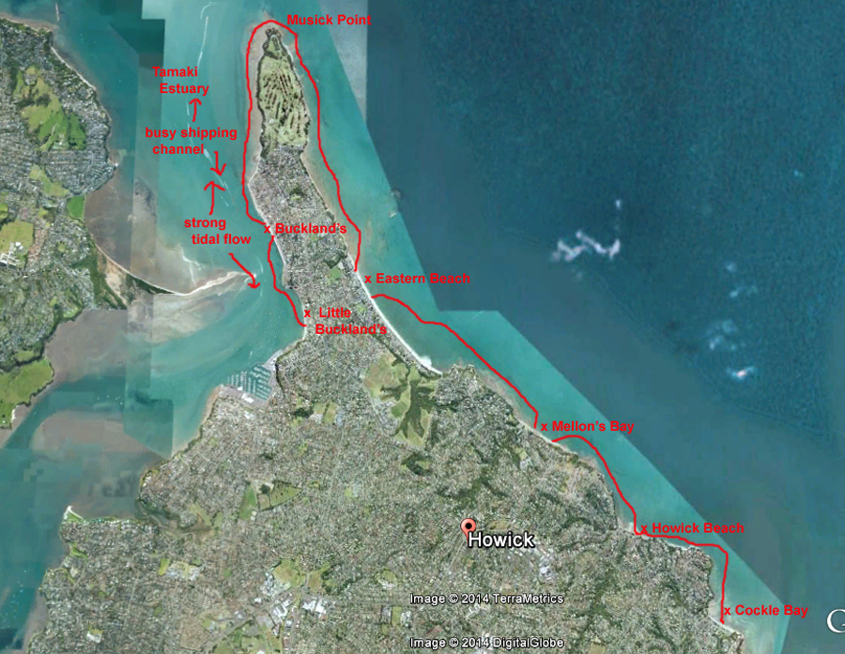

Additional Information Sheet (Optional)
Introduction (A general introduction)
Description (A description of the tour – as if you were selling the idea to someone)
Local Attractions |  | Transport/ Local Operators
 | Contact details |  | Contact details
Local Eateries
 | Contact details
Accommodation/ Campsite Locations |  |  | Facilities
Name |  |  | Cabins |  | Fuel
Phone |  |  | Showers |  | Power
E-mail |  |  | Toilets |  | Water Access
Website |  |  | Laundry |  | Pool
Physical Address |  |  | Water |  | Fires Allowed
Other |  |  | Supplies
Other information

Activity Equipment Check list
Equipment List
- Helmet (rivers & surf) Group Gear
❑ Beanie / hat  Split paddles
❑ Thermals  Repair kit
❑ Paddle Jacket  Fire lighting
❑ PFD  Cooker/thermos
❑ Spray deck  Spare thermals
❑ Booties  Tow system
❑ Water & food  1st Aid Kit
❑ Kayak & paddle  Flares
Group - Oceans & Lakes  Compass
❑ Pumps & Paddle Floats  Charts / Maps
Group - River  GPS (optional)
❑ Throw ropes  Knife (cut rope)
❑ Pin kit & saw  Emergency Shelter

In case of emergency: Dial 111, Mayday :VHF Channel 16

Kayaking Check list

❑ Trip plan
❑ Latest weather forecast
❑ Conditions match skills?
❑ Hyperthermia (hot) &
Hypothermia (cold)
❑ On & off water safety
❑ Environmental concerns
❑ Emergency Procedures include emergency get out.
❑ Working communication devices
e.g. VHF radio, mobile phones, PLB
❑ Specific safety issues for this trip
❑ Participant list
❑ Any medical conditions
❑ All participants keen to proceed?

❑ Trip Plan/ 2-minute form lodged with Ops. Manager

Appropriate wind conditions to run trips:
Novice - no significant surf or swell, wind under 15knots
Intermediate- surf or ocean swells less than 1.5 metre or wind under 25 knots.
Advanced- any condition that is suitable to the trips aims

At conclusion of trip:
Contact check in person
Group Debrief.

Check in Person Ph:
__________________ Mobile
__________________ Work
__________________ Home

Activity Document Cover Sheet

Activity:
Date of Activity:

Activity reports. Is all relevant information present:
– Approved Trip Management Plan (TMP)/ 2 minute form
– Club Trip Participant Sheet
– Weather forecast
– Activity Check List
– Trip report (May be on the 2 minute form)
– Accident / incident reports
Leaders Signature:
Date:

